Parole in libertà
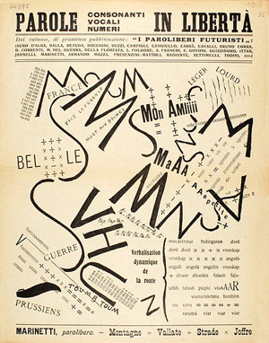
http://www.monografica.org/02/Art%C3%ADculo/3201

Translatable as “words in freedom” or “liberated words”, the phrase is an essential slogan of the Italian Futurist movement, and refers to a radical new way of using literary language and liberating it from the bounds of tradition. First coined by Filippo Tommaso Marinetti in the “Technical Manifesto of Futurist Literature” (1912) and further defined in texts such as “Destruction of Syntax/Imagination without Strings/ Words-in-Freedom” (1913) and “Geometric and Mechanical Splendor and the Numerical Sensibility” (1914), the phrase has come to define the entire futurist aesthetic of visual language. The technique primarily applies to the invention of specific tables of words (tavole parolibere) artfully arranged in typographical innovative patterns (e.g. through the procedure of “typographic analogy”, where, the verb “to go down” has to graphically mimic the action of descending).
Among the techniques involved by the method prescribed by the manifestos are the exclusive use of verbal infinitive, the abolition of adjectives, adverbs and punctuation, and the intense use of onomatopoeic words. The noun gains absolute primacy, putting reality starkly on the page. Words are mainly connected through analogy, juxtaposed without conjunctions or logical connectors (e.g. “uomo-torpediniera”, “man-torpedo boat”). Together with the destruction of syntax, the destruction of traditional subjectivity is pursued, by replacing logical patterns of thought with intuition and a “wireless imagination”.

Further Reading
Caruso, L., Martini, S.M. (ed.) (1974), Tavole parolibere futuriste (1912-1944). Napoli: Liguori Editore.
Viazzi, G. (ed.) (1978), I poeti del futurismo, 1909-1944. Milano: Longanesi.
Apollonio, U. (ed.) (2001), Futurist Manifestoes. Boston: MFA Publications.
Flint, W. (ed.) (1972), Marinetti: Selected Writings. New York: Farrar, Straus and Giroux.

